Optional Lab: Learn a New Programming Language

**OVERVIEW & PURPOSE**

Once you have mastered the basics of one high level programming language, you should be able to easily code in another. In this lab, you will choose a new programming language to explore that we have not yet covered. (C++, Java, Ruby, etc..) and answer the questions below.

**ACTIVITY**

1. What language did you choose?

**I have chosen programming language of C#**

1. Find the language’s official website and paste the link?

<https://msdn.microsoft.com/en-us/library/a72418yk.aspx>

1. How do you say ‘Hello World’ in this language. Write the code, run, and display it.

using System;

namespace Hello

{

class Program

{

static void Main(string[] args)

{

Console.WriteLine("Hello World !");

}

}

}

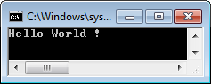

1. What is the syntax for assigning the numerical value 1 in this language?

int n = 1;

1. What is the syntax for assigning the string value 1 in this language?

string s = "1";

1. Does this language support classes? What is a class?

**Yes, C# support class. In fact it is pure OOP language. Main function inside the class is executed.**

1. Find a built in function and explain what it does.

**Max function find the maximum of given two numbers and returns it. Max function is located inside the Math class. So we should call it Math.Max. We can assign the returned value to variable and display it**

**int max = Math.Max(45, 28);**

**Console.WriteLine(max);**

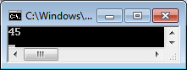

1. Is this a compiled or interpreted language?

**It is compiled language.**

1. Are data types explicit or implicit?

**You declare data types explicitly in C#. Otherwise it will give error. There is implicit version declaring the variable using var keyword as well but you should give a value while declaring it and it will automatically finds out which data type you are intending to use.**

1. What is the syntax for creating a loop?

**You use for keyword, then declare and initialize the loop variable, you set the condition of the loop and you set the changing of the loop variable.**

for (int i = 0; i < 10; i++)

{

Console.Write(i+" ");

}

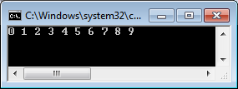

1. What is the syntax for creating an if else statement?

**It is the same as in JavaScript, after if you write the condition in parenthesis. There is optional else statement as well.**

int score = 92;

if (score > 85) Console.WriteLine("Excellent");

else Console.WriteLine("Not Excellent");

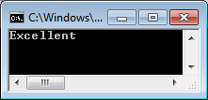

1. How do you comment in this language?

We comment using double forward slash //

//for (int i = 0; i < 10; i++)

//{

// Console.Write(i+" ");

//}

int score = 92;

if (score > 85) Console.WriteLine("Excellent");

else Console.WriteLine("Not Excellent");

1. How do you store multiple items in one variable? Ex. 5 distinct number.

**You declare an array.**

int[] numbers = { 10,20,30,40,50};

1. Find an online tutorial for this language. Do you think that you could learn a programming language on your own?

There are a lot of online tutorials

<https://www.tutorialspoint.com/csharp/>

<http://www.learncs.org/>

**In the last one you can even compile the programs online. But, I didn’t know that before and installed free version of Visual Studio on my laptop.**

**Yes, I can learn this language on my own. I can search any thing I want on the internet and usually stackoverflow gives the answer.**